

**COMP 1030**

**Lab #1**

**This lab requires the windows OS**

***Purpose***

The purpose of this lab is to confirm that the java development kit (JDK) is installed on your computer. If it is not installed you will download it and set up the PATH variable on your computer so that the java compiler (javac) can be executed from any directory. Once the JDK is set up you will write and execute your first java program. Once completed, you will use the javadoc application to automatically create an HTML document of your program.

**Challenge 1**

In this challenge you will confirm if the JDK is installed on your computer.

Step 1: Open the MS-DOS command window by typing CMD in the windows search field in the bottom left of your screen. Once launched you will see this window:

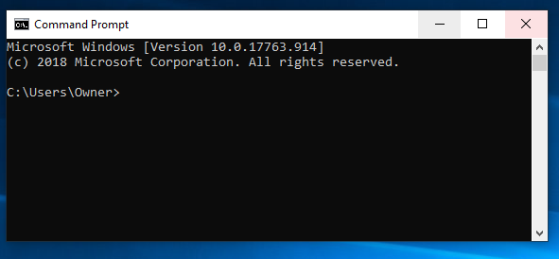

Step 2: In the command window type “javac”. If the JDK is NOT installed you will receive a message like this:

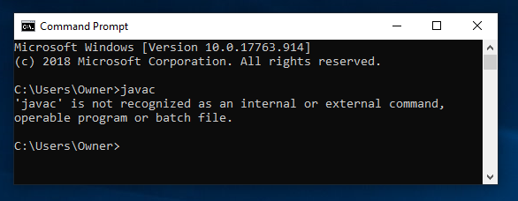

Therefore, proceed to challenge 2.

If the JDK is set up on your machine you will get a long list of usage options that begin like this:

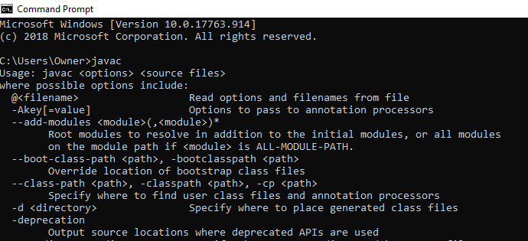

The above message indicates that the JDK is already set up on your machine, in which case

proceed to challenge 3.

**Challenge 2**

In this challenge you will download the JDK and set up the PATH system variable such that you can launch the

Java compiler (javac) from any directory within your computer.

Step 1: Go to one of the following websites (or a site of your choosing) and download the latest version of the JDK.

<https://www.oracle.com/technetwork/java/javase/downloads/index.html>

<https://www.techspot.com/downloads/5553-java-jdk.html>

Depending on which site you choose you may have to set up an account. Once the JDK is downloaded

you will need to change the PATH system variable to point to the actual location of javac.exe on your

computer so the OS can find this application from anywhere on your computer.

Step 2: Use the CMD window to find the javac.exe application. Here are the commands you will need to accomplish this task:

cd.. – will move you up one directory

cd <directory name> will move you into the directory named

dir – will list the contents of the directory.

* - means a wild card

Essentially you will first cd to the top directory (c:\) and then look for javac.exe from there.

Your journey will look something like this:

cd.. until I get to c:\

Then type dir to see what is in this directory

Make a guess at what Directory java may live in then cd to that directory

Repeat these steps until you find javac.exe

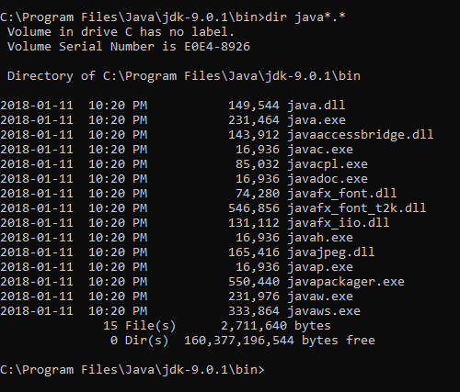

From this example you can see that javac.exe lives in: C:\Program Files\Java\jdk-9.0.1\bin>

Therefore this is the path that needs to be added to the PATH system variable.

Step 3: To add this path to the PATH system variable open the environment variable dialog box

by typing “system environment variable” in the windows search field in the lower left of your screen.

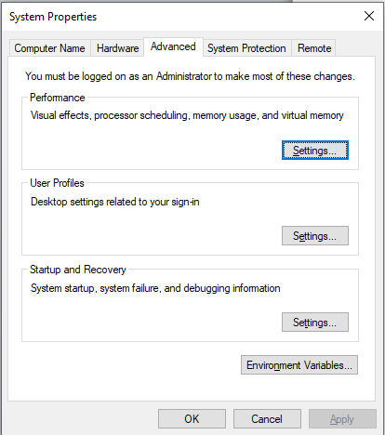

Step 4: Click on the environment variable button in the bottom right.

Step 5: Select the Path **system variable** and click on the edit button.

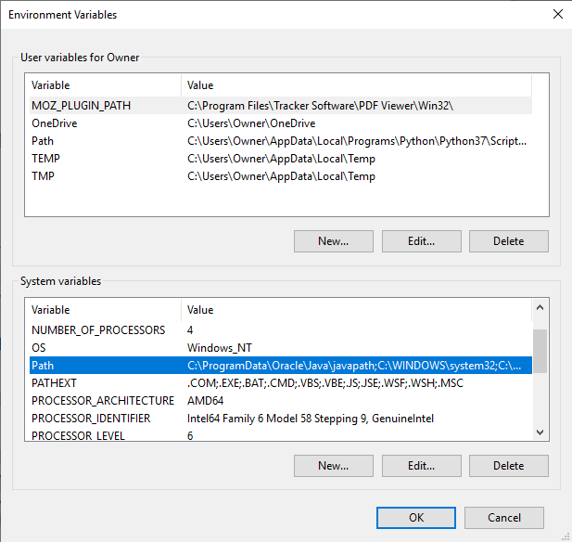

Step 6: Add the path that you determined in step 2 to the system variable.

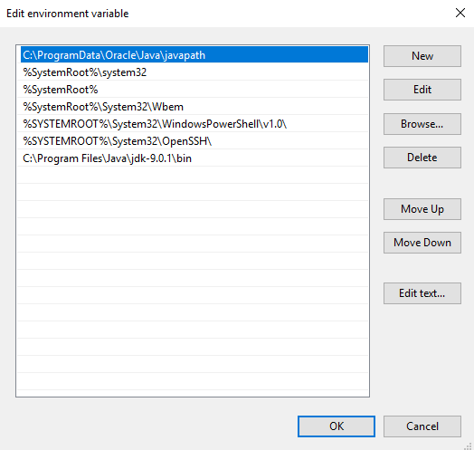

Step 7: Click OK on all of the dialog boxes to exit the editing process.

Step 8: Exit the CMD window and open a new one.

Step 9: Type “javac” to confirm that the java compiler can now be run from anywhere on your machine. If this does not work confirm that the system variable has been changed properly. You may also have to google your actual computer to confirm how to change the system variable as it may be different for your machine.

**Challenge 3**

In this challenge you will create a new directory using the CMD prompt. Once the new directory is

created you will copy a java program into a text editor, save, compile and then run the program and verify

its output.

Step 1: Open the CMD prompt.

Step 2: cd to the root directory (c:\)

Step 3: Create a new directory called COMP1030 using the following command:

mkdir comp1030

Step 4: cd to the new directory using the cd <directory name> command.

Step 5: Create a new directory within the COMP1030 directory called week1

Step 6: Open notepad and type in the following simple java program **exactly** as it appears:

public class HelloWorld

{

public static void **main**(String[] args)

{

System.out.**println**("Hello, World");

}

}

Step 7: Save the file as HelloWorld.java in the directory called week1

Step 8: Open the CMD prompt if it is not already open

Step 9: CD to the directory in which the HelloWorld.java file is saved. Confirm that there are no other files in this directory.

Step 10: Compile the HelloWorld.java file by running the java compiler (javac HelloWorld.java)

Step 11: Determine the files that now sit in the directory and list your answer here:

File 1:________________

File 2:________________

Step 12: Run your program using the java command: (java HelloWorld) . Notice the output which appears in the cmd window.

Step 13: Modify the program such that instead of printing “hello world” it prints your name.

**Challenge 4**

In this challenge you will create HTML documentation of your first java program.

Step 1: Open the CMD prompt if it is not already open

Step 2: CD to the week1 directory

Step 3: Create documentation for your program by running the Javadoc command in the terminal window. (Javadoc HelloWorld.java)

Step 4: Open a browser and view your documentation by referencing the index.html file that was just created.